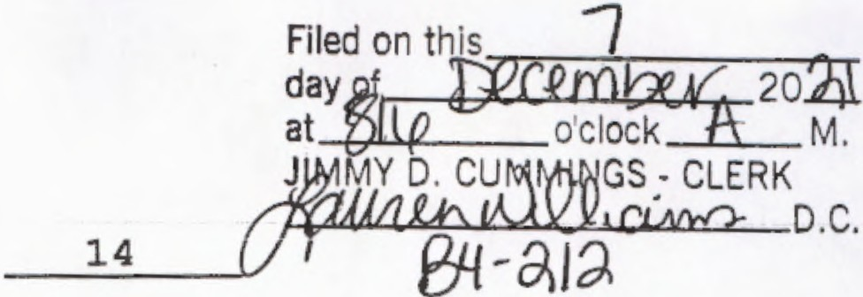
ORDINANCE# 2021 -

BE ENACTED BY THE QUORUM COURT OF CLEVELAND COUNTY, ARKANSAS , AN ORDINANCE TO BE ENTITLED: "AN ORDINANCE TO ESTABLISH THE ANNUAL OPERATING BUDGET OF CLEVELAND COUNTY, ARKANSAS, FOR THE FISCAL YEAR 2022:"

SECTION ONE. ANNUAL BUDGET ADOPTED BY REFERENCE. The annual
budget for Fiscal Year 2022, as identified as "2022 Annual Budget, Cleveland County, Arkansas," dated 6 December 2021, is hereby adopted by reference. A copy of said Budget Ordinance is available for inspection, copying by any person during normal business hours at the Cleveland County Clerk's Office and available online at https://clevelandcounty.arkansas.gov.

SECTION TWO. NON-RESTRICTED EXPENDITURE CATEGORIES .
Expenditures of funds appropriated by this Ordinance shall not be re tricted to the line item Personal Services , Supplies, Other Service and Charges , and Capital Outlays, but shall not be restricted to categories or expenditures, except for funds appropriated for personnel salaries and wages and related employee benefits. Personnel expenditures shall not exceed the dollar amounts, number of employees and salary or wage rates specified in the annual budget or an amendment thereto.

SECTION THREE . EXPENDITURES RESTRICTED TO SPECIFIC FUND. No
expenditures of appropriated funds shall be made from any fund other than the fund specified in this Ordinance or an amendment thereto.

SECTION FOUR. TRANSFERS. Any transfer of monies between the various funds of the county between the four major categories of expenditures (Personal Services, Supplies, Other Services and Charges , and Capital Outlays) shall be made only with prior approval of the Cleveland County Quorum Court. Provided, however all transfers budgeted for in the annual budget shall be exempt from the provisions of this section.

SECTION FIVE. MAXIMUM APPROPRIATED AMOUNTS.

A. COUNTY GENERAL FUND 1000
Total Projected County General Fund Revenues | $2,377,212
Ninety percent (90%) of Projected Revenues | $2,139,491
Total Projected Expenditures | $2,094,876
TOTAL NON-APPROPRIATED | $ 38,615

OFFICE/DEPARTMENT

COUNTY JUDGE'S OFFICE | Personal Services | $35,054
1000 -0100 | Supplies | $ 1,075
 | Other Services & Charges | $ 5, 486
 | Capital Outlays | $ 500
 | TOTAL | $42 ,115
COUNTY CLERK'S OFFICE | Personal Services | $188 ,137
1000-0101 | Supplies | $ 2,205
 | Other Services & Charges | $21,740
 | TOTAL | $212,082
CIRCUIT CLERK'S OFFICE | Personal Services | $ 984
1000 -0102 | Supplies | $ 2 ,265
 | Other Services & Charges | $22,077
 | TOTAL | $25,326
TREASURER'S OFFICE | Personal Services | $81,550
1000-0103 | Supplies | $ 154
 | Other Services & Charges | $ 2,842
 | TOTAL | $84 , 546
COLLECTOR' S OFFICE | Personal Services | $105,701
1000-0104 | Supplies | $ 2,680
 | Other Services & Charges | $12 ,966
 | TOTAL | $121,347
ASSESSOR' S OFFICE | Personal Services | $114,713
1000-0105 | Supplies | $ 3,083
 | Other Services & Charges | $27,400
 | TOTAL | $145,196
BOARD OF EQUALIZATION | Personal Services | $ 1,090
1000-0106 | Other Services & Charges | $ 200
 | TOTAL | $ 1,290
QUORUM COURT | Personal Services | $19,400
100-0107 | Supplies | $ 50
 | Other Services & Charges | $ 2,910
 | TOTAL | $22,360
COURTHOUSE MAINTENANCE | Personal Services | $21,158
1000-0108 | Supplies | $ 6,550
 | Other Services & Charges | $31,450
 | TOTAL | $59 ,158

ELECTIONS |  | Personal Services |  | $42,060
1000-0109 |  | Supplies |  | $ 7,000
 |  | Other Services & | Charges | $27,700
 |  | TOTAL |  | $76,760
COUNTY BUILDINGS |  | Supplies |  | $ 3,000
1000-0111 |  | Other Services & | Charges | $ 1,000
 |  | Capital Outlay |  | $ 4,000
 |  | TOTAL |  | $ 8,000
GRANTS-IN-AID |  | Other Services & | Charges | $22,000
1000-0116 |  | TOTAL |  | $22,000
COUNTY REAPPRAISAL |  | Other Services & | Charges | $84,288
1000-0117 |  | TOTAL |  | $84,288
HEALTH DEPARTMENT |  | Supplies |  | $ 4,939
1000 -0300 |  | Other Services & | Charges | $11,551
 |  | TOTAL |  | $16,490
SHERIFF'S | OFFICE | Personal Services |  | $570,319
1000-0400 |  | Supplies |  | $69,500
 |  | Other Services & Charges |  | $23,753
 |  | Capital Outlays |  | $1,000
 |  | TOTAL |  | $664,572
DISTRICT COURT |  | Personal Services |  | $79,871
1000-0409 |  | Supplies |  | $ 147
 |  | Other Services & Charges |  | $20,618
 |  | TOTAL |  | $100,636
JUVENILE COURT |  | Personal Services |  | $44,321
1000-0415 |  | Supplies |  | $ 150
 |  | Other Services & Charges |  | $ 2,934
 |  | TOTAL |  | $47,405
PROSECUTING ATTORNEY |  | Other Services & Charges |  | $14,100
1000-0416 |  | TOTAL |  | $14,100
JAIL |  | Personal Services |  | $182,161
1000-0418 |  | Supplies |  | $ 1,900
 |  | Other Services & Charges |  | $44,055
 |  | Capital Outlays |  | $ 5,000
 |  | TOTAL |  | $233,116

3

-

COUNTY CORONER | Personal Services | $ 7,384
1000-0419 | Supplies | $ 2,800
 | Other Services & Charges | $ 4,225
 | TOTAL | $14,409
O.E.M. | Personal Services | $23,664
1000-0500 | Supplies | $ 6,450
 | Other Services & Charges | $ 9,525
 | Capital Outlays | $0
 | TOTAL | $39,639
VETERAN'S OFFICE | Personal Services | $12,843
1000-0800 | Supplies | $ 600
 | Other Services & Charges | $ 7,208
 | TOTAL | $20,651
EXTENSION OFFICE | Supplies | $ 750
1000-0801 | Other Services & Charges | $37,890
 | TOTAL | $38,640
PAUPERS & WELFARE | Other Services & Charges | $ 750
 | TOTAL | $ 750

COUNTY GENERAL
TOTAL PROJECTED EXPENDITURES/TRANSFERS

$2,094,876

B. | CORONAVIRUS RELIEF FUND 1005
 | Total Projected Revenues |  | $391,599.88
 | Ninety percent (90%)of Projected | Revenue | N/A
 | Total Projected Expenditures |  | $150,000
 | Total Non-Appropriated |  | $241,599.88

Capital Outlays TOTAL
$150,000
$150,000

C. | HOSPITAL MAINTENANCE 1800  Total Projected Revenues |  | $17,100
 | Ninety percent (90%) of Projected | Revenue | $15,390
 | Total Projected Expenditures |  | $ 2,550
 | Total Non-Appropriated |  | $12,840
Personal Services |  |  | $ 2,000
Supplies |  |  | $ 500
Other Services & Charges |  |  | $ 50
TOTAL |  |  | $ 2,550

D. | WORKERS COMPENSATION FUND 1801
 | Total Projected Revenues |  |  | $15,680
 | Ninety percent (90%) of Projected |  | Revenue | $14,112
 | Total Projected Expenditures |  |  | $ 2,500
 | Total Non -Appropriated |  |  | $11,612
Personal |  | Services | $ 2,500
TOTAL |  |  | $ 2,500

E. ARP LOSS OF REVENUE FUND 1807
Total Projected Revenues
Ninety percent (90%) of Projected Revenue Total Projected Expenditures
Total Non-Appropriated

$90,509
$15,390
$73,750
$12,840

Capital |  | Outlays | $73,750
TOTAL |  |  | $73,750
F. | COUNTY ROAD DEPARTMENT FUND 2000
 | Total Projected Revenues |  |  | $2,062,500
 | Ninety percent (90%) Projected |  | Revenue | $1,856,250
 | Total Projected Expenditures |  |  | $1,837,700
 | Total Non-Appropriated |  |  | $ 18,550
Personal |  | Services | $799 ,034
Supplies |  |  | $710,200
Other Services & |  |  | Charges | $ 55,816
Capital Outlays |  |  |  | $121,650
Debt Service |  |  |  | $151,000
TOTAL |  |  |  | $1,837,700
G. ADDITIONAL MOTOR FUEL TAX (ACT 416 OF |  |  | 2019) FUND | 2003
Total Projected Revenues |  |  |  | $232,792
Ninety percent (90%) Projected |  |  | Revenue | $209,512
Total Projected Expenditures |  |  |  | $209,500
Total Non-Appropriated |  |  |  | $ 12
Supplies |  |  |  | $209,500
TOTAL |  |  |  | $209,500

H. | TREASURER'S AUTOMATION FUND 3000
 | Total Projected Revenues |  | $19 ,277
 | Ninety percent (90%) of Projected | Revenue | $17,349
 | Total Projected Expenditures |  | $ 8,733
 | Total Non-Appropriated |  | $ 8,616

Supplies
Other Services & Charges TOTAL

I . COLLECTOR'S AUTOMATION FUND 3001
$1,000
$ 7,233
$ 8,733

Total Projected Revenues |  |  |  | $51,000
Ninety percent (90%) of Projected |  |  | Revenue | $45,900
Total Projected Expenditures |  |  |  | $16,750
Total Non-Appropriated |  |  |  | $29 ,150
Personal Services |  |  |  | $1,000
Supplies |  |  |  | $ 2,250
Other Services & |  | Charges |  | $13,500
TOTAL |  |  |  | $16,750
J . | CIRCUIT COURT AUTOMATION FUND 3002
 | Total Projected Revenues |  |  | $ 442
 | Ninety percent (90%) of Projected |  | Revenue | $ 397
 | Total Projected Expenditures |  |  | $ 160
 | Total Non-Appropriated |  |  | $ 237
 | Supplies |  |  | $ 160
 | TOTAL |  |  | $ 160

K. DISTRICT COURT AUTOMATION FUND 3003
Total Projected Revenues |  |  | $13,500
Ninety percent (90%) of Projected |  | Revenue | $12,150
Total Projected Expenditures |  |  | $ 9,050
Total Non-Appropriated |  |  | $ 3,100
Supplies |  |  | $ 1,950
Other Services | & Charges |  | $ 7,100
TOTAL |  |  | $ 9 ,050

6

L. | ASSESSOR'S AMENDMENT 79 FUND 3004
 | Total Projected Revenues |  |  |  | $13,400
 | Ninety percent (90%) of Projected |  |  | Revenue | $12,060
 | Total Projected Expenditures |  |  |  | $ 6,326
 | Total Non-Appropriated |  |  |  | $ 5,734
Personal |  | Services |  | $ 3,326
Supplies |  |  |  | $ 3,000
TOTAL |  |  |  | $ 6, 326
M. | RECORDER'S COST FUND 3006
 | Total Projected Revenues |  |  |  | $74,385
 | Ninety percent {90%) of Projected |  |  | Revenue | $66,946
 | Total Projected Expenditures |  |  |  | $57,896
 | Total Non-Appropriated |  |  |  | $ 9,050
Personal Services |  |  |  |  | $39,346
Supplies |  |  |  |  | $ 3,160
Other Services & |  |  | Charges |  | $15,300
TOTAL |  |  |  |  | $57,896
N. | COUNTY LIBRARY FUND 3008
 | Total Projected Revenues |  |  |  | $203,467
 | Ninety percent (90%) of Projected |  |  | Revenue | $183,120
 | Total Projected Expenditures |  |  |  | $124,784
 | Total Non-Appropriated |  |  |  | $58 ,336
Personal |  | Services | $70,044
Supplies |  |  | $30,200
Other Services & |  |  | Charges |  | $20,540
Capital Outlays |  |  |  |  | $ 4,000
TOTAL |  |  |  |  | $124,784

0. SOLID WASTE FUND 3009
Total Projected Revenues

$1 ,846,000

Ninety percent (90%) of Projected | Revenue | $1 ,661,400
Total Projected Expenditures |  | $869 ,558
Total Non-Appropriated |  | $791,842
Personal Services |  | $ 96,475
Supplies |  | $ 11,000
Other Services & Charges |  | $762,083
TOTAL |  | $869,558

P. | COUNTY CLERK OPERATING FUND 3010
 | Total Projected Revenues |  |  | $ 775
 | Ninety percent (90%) of Projected |  | Revenues | $ 697
 | Total Projected Expenditures |  |  | 400
 | Total Non-Appropriated |  |  | $ 297
 | Supplies |  |  | $ 400
 | TOTAL |  |  | $ 400
Q. | CHILD SUPPORT FUND 3012
 | Total Projected Revenues |  |  | $ 6,900
 | Ninety percent (90%) of Projected |  | Revenues | $ 6,210
 | Total Projected Expenditures |  |  | $ 2,860
 | Total Non-Appropriated |  |  | $ 3,350
Supplies |  |  |  | $ 2,500
Other Services |  | & Charges |  | $ 360
TOTAL |  |  |  | $ 2,860
R. | COMMUNICATIONS & FACILITY EQUIPMENT FUND 3014
 | Total Projected Revenues |  |  | $52,600
 | Ninety percent (90%) of Projected |  | Revenues | $47,340
 | Total Projected Expenditures |  |  | $12,000
 | Total Non-Appropriated |  |  | $35,340
Supplies |  | $ 7,000
Capital Outlays |  | $ 5,000
TOTAL |  | $12,000

S. JAIL OPERATION AND MAINTENANCE FUND 3017
Total Projected Revenues |  | $106,000
Ninety percent (90%) of Projected | Revenue | $95,400
Total Projected Expenditures |  | $46,500
Total Non-Appropriated |  | $48,900

Supplies
Other Services & Charges Capital Outlays
TOTAL
$22,500
$23,000
$1,000
$46,500

T. | BOATING SAFETY FUND 3019
 | Total Projected Revenues |  | $ 6,200
 | Ninety percent (90%) of Projected | Revenues | $ 5,580
 | Total Projected Expenditures |  | $ 1,000
 | Total Non-Appropriated |  | $ 4,580

Capital Outlays TOTAL
$ 1,000
.$ 1,000

U. | 911 PUBLIC SAFETY FUND 3020
 | Total Projected Revenues |  | $238,497
 | Ninety percent (90%) of Projected | Revenue | $214,647
 | Total Projected Expenditures |  | $214,074
 | Total Non-Appropriated |  | $ 573

Personal Services $188,574
Supplies |  |  |  | .$20,400
Other Services & Charges |  |  |  | $ 5,100
TOTAL |  |  |  | $214,074
V. | INDIGENT CRIMINAL DEFENSE FUND 3026
 | Total Projected Revenues |  |  | $ 9,200
 | Ninety percent (90%) of Projected |  | Revenue | .$ 8,280
 | Total Projected Expenditures |  |  | $ 8,000
 | Total Non-Appropriated |  |  | $ 280
Supplies |  |  |  | $ 800
Other Services |  | & Charges |  | .$ 7,200
TOTAL |  |  |  | $ 8,000
W. | JlNENILE PROBATION FUND 3031
 | Total Projected Revenues |  |  | $ 3,030
 | Ninety percent (90%) of Projected |  | Revenue | $ 2,727
 | Total Projected Expenditures |  |  | $ 2,000
 | Total Non-Appropriated |  |  | $ 727
Supplies |  |  |  | $ 1,000
Other Services |  | & Charges |  | $ 1,000
TOTAL |  |  |  | $ 2,000

X. | J1NENILE COURT REPRESENTATION FUND 3032
 | Total Projected Revenues |  | $ 68
 | Ninety percent (90%) of Projected | Revenue | $ 62
 | Total Projected Expenditures |  | $ 60
 | Total Non-Appropriated |  | $ 2
 | Supplies |  | $ 60
 | TOTAL |  | $ 60

Y. CIRCUIT CLERK COMMISSIONER'S FEE FUND 3039
Total Projected Revenues | $ 497
Ninety percent (90%) of Projected Revenue | $ 447
Total Projected Expenditures | $ 300
Total Non -Appropriated | $ 147
Other Services & Charges | $ 300
TOTAL | $ 300
Z. ASSESSOR'S LATE ASSESSMENT FEE FUND 3042
Total Projected Revenues | $ 1,200
Ninety percent (90%) of Projected Revenue | $ 1,080
Total Projected Expenditures | $ 1,000
Total Non-Appropriated | $ 80
Su pplies | $ 1,000
TOTAL | $ 1,000
Y. AMERICAN RESCUE PLAN FUND 3046
Total Projected Revenues | $337,733.77
Ninety percent (90%) of Projected Revenue | $ N/A
Total Projected Expenditures | $337,733.77
Total Non-Appropriated | $ N/A
Capital Outlays | $ 337 ,733 .77
TOTAL | $337,733.77
Z. AMBULANCE SERVICE FUND 3400
Total Projected Revenues | $445,000
Ninety percent (90%) of Projected Revenue | $400,500
Total Projected Expenditures | $97,200
Total Non-Appropriated | $263 ,100
Supplies | $ 1,000
Other Services & Charges | $95,400
Capital Outlays | $ 1,000
TOTAL | $97,400

X. | SHERIFF'S EQUIPMENT FUND 3401
 | Total Projected Revenues |  | $152,332
 | Ninety percent (90%) of Projected | Revenue | $137,098
 | Total Projected Expenditures |  | $ 90,000
 | Total Non-Appropriated |  | $ 47,098

Capital Outlays TOTAL
$ 90,000
$ 90,000

Z. | SPECIAL JAIL FEES FUND 3402
 | Total Projected Revenues |  | $ 2,100
 | Ninety percent (90%) of Projected | Revenue | $ 1,890
 | Total Projected Expenditures |  | $ 0
 | Total Non-Appropriated |  | $ 1,890

Other Services & Charges $ 0 TOTAL i Q

BB. | ADDITIONAL DISTRICT JUDGE RETIREMENT FUND 3404  Total Projected Revenues |  | $ 76,500
 | Ninety percent (90%) of Projected Revenue |  | $ 68,850
 | Total Projected Expenditures |  | $ 20,000
 | Total Non-Appropriated |  | $ 48850
Other Services |  | & Charges | $ 20,000
TOTAL |  |  | $ 20,000

DD. | SOLID WASTE RECYCL ING GRANT 3515  Total Projected Revenues |  | $ 66,758
 | Ninety percent (90%) of Projected | Revenue | $ 60,082
 | Total Projected Expenditures |  | $ 59,500
 | Total Non-Appropriated |  | $ 582
Personal Services |  |  | $ 2,000
Supplies |  |  | $ 2,000
Other Services & Charges |  |  | $ 5,500
Capital Outlays |  |  | $ 50,000
TOTAL |  |  | $ 59,500

EE. AUTOMATED RECORDS SYSTEMS GRANT FUND 3524
Total Projected Revenues
Ninety percent (90%) of Projected Revenue Total Projected Expenditures
Total Non-Appropriated

Other Services & Charges TOTAL

EE. BLUE AND YOU FOUNDATION GRANTS FUND 3529
Total Projected Revenues
Ninety percent (90%) of Projected Revenue Total Projected Expenditures
Total Non-Appropriated

Other Services & Charges TOTAL
EE. WALMART COMMUNITY GRANT FUND 3532
Total Projected Revenues
Ninety percent (90%) of Projected Revenue Total Projected Expenditures
Total Non-Appropriated

Other Services & Charges TOTAL

FF . ENTERGY MICRO GRANT FUND 3533
Total Projected Revenues
Ninety percent (90%) of Projected Revenue Total Projected Expenditures
Total Non-Appropriated

Other Services & Charges TOTAL

GG. ENTERGY MICRO GRANT-VA FUND 3534
Total Projected Revenues
Ninety percent (90%) of Projected Revenue Total Projected Expenditures
Total Non-Appropriated

Other Services & Charges TOTAL

$30,969.20
Waived
$30,969.20
NIA

$
$30,969.20

$ 902.65
Waived
$ 902.65
N/A

$ 902.65
$ 902.65

$178.19
Waived
$ 178.19
N/A

$ 178.19
$ 178.19

$ 500
Waived
$ 500

N/A

$ 500
$ 500

$ 800
Waived
$ 800
N/A

$ 800
$ 800

SECTION SIX. If any provision of this Ordinance or the application thereof to any person or circumstance is held invalid, such invalidity shall not affect other provisions or applications of the Ordinance which can be given effect without the invalid provisions or application, and to this end, the provisions of this Ordinance are declared to be severable.

SECTION SEVEN. This Ordinance being necessary for the protection and preservation of public health and safety, an emergency is declared to exist and this Ordinance is to be in full force and effect from and after the date of its passage and approval.

Dated this 6th day of December, in the Year of our Lord, Two Thousand and Twenty One.
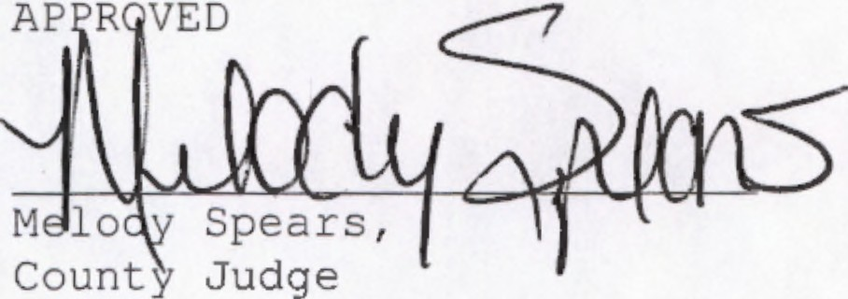
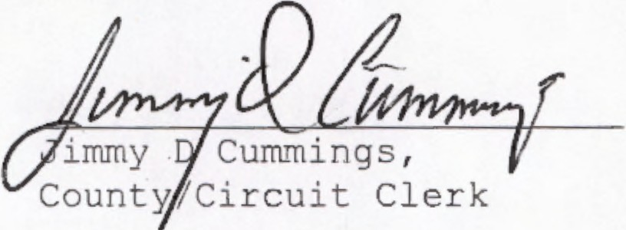
ATTEST

