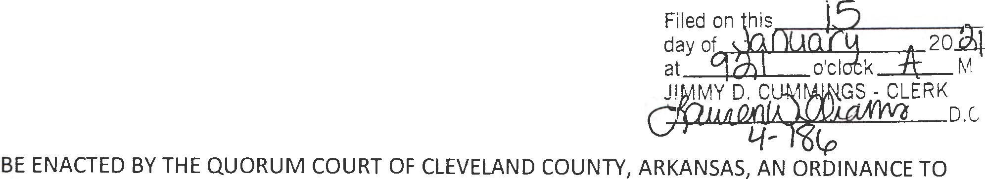
ORDINANCE # 2021 - 4

BE ENTITLED:

AN ORDINANCE TO AMEND THE ANNUAL OPERATING BUDGET OF CLEVELAND COUNTY, ARKANSAS, FOR THE FISCAL YEAR 2020:

SECTION ONE. Fund 1000 - County General.

From Appropriated:

$1,601 | to 1000-0100-1001from 1000-0101-1001
$367 | to 1000-0100-1002 from 1000-0101-1001
$120 | to 1000-0100-1006 from 1000-0101-1001
$377 | to 1000-0100-1008 from 1000-0101-1001
$200 | to 1000-0100-2001 from 1000-0100-4004
$111 | to 1000-0100-3010 from 1000-0100-4004
$130 | to 1000-0101-1002 from 1000-0101-1001
$15 | to 1000-0101-1008 from 1000-0101-1001
$100 | to 1000-0102-1002 from 1000-0102-2001 .
$5 | to 1000-0102-1006 from 1000-0102-2001
$15 | to 1000-0102-1008 from 1000-0102-2001
$10 | to 1000-0102-1010 from 1000-0102-2001

$2946 to 1000-0103-1001 from 1000-0103-1009
$108 to 1000-0103-1002 from 1000-0103-1009
$470 to 1000-0103-1008 from 1000-0103-3090
$35 | to 1000-0103-2003 from 1000-0103-3090
$4,237 | to 1000-0104-1001 from 1000-0101-1001
$100 | to 1000-0104-1002 from 1000-0104-3020
$180 | to 1000-0104-1006 from 1000-0104-3020
$1,675 | to 1000-0104-1008 from 1000-0104-3040
$3,694 | to 1000-0105-1001 from 1000-0105-1002
$1,720 | to 1000-0105-1008 from 1000-0101-1009
$400 | to 1000-0106-1002 from 1000-0106-1001
$1375 | to 1000-0107-1001 from 1000-0107-1002
$30 | to 1000-0107-2001 from 1000-0107-3030
$9,123 | to 1000-0109-1002 from 1000-0109-1003
$1,081 | to 1000=0109-2001 from 1000-0109-1003

$1,230 | to 1000-0400-3053 from 1000-0400-2024
$3,126 | to 1000-0409-1001from 1000-0400-1009
$276 | to 1000-0409-1006 from 1000-0400-1009
$554 | to 1000-0409-1008 from 1000-0400-1009
$84 | to 1000-0409-2001 from 1000-0400-1009
$555 | to 1000-0409-3017 from 1000-0400-1009
$1,342 | to 1000-0415-1001 from 1000-0415-1009
$60 | to 1000-0415-1006 from 1000-0415-1009
$206 | to 1000-0415-1008 from 1000-0415-1009
$825 | to 1000-0418-1002 from 1000-0418-1001
$220 | to 1000-0418-2001 from 1000-0418-1001
$910 | to 1000-0419-1001 from 1000 -0419-2023
$75 | to 1000-0419-1006 from 1000-0419-2023
$860 | to 1000-0500-1001 from 1000-0108-3060
$50 | to 1000-0500-1006 from 1000-0108-3060
$135 | to 1000-0500-1008 from 1000-0108-3060
$50 | to 1000-0500-1010 from 1000-0108-3060
$7,700 to 1000-0500-2001 from 1000-0108-3060

$20 to 1000-0800-2001from 1000-0800-1001

$2,200 to 2000-0200-1005 from 2000-0200-1009
$22,000 to 2000-0200-5005 from 2000-0200-2007
$7,000 to 2000-0200-5006 from 2000-0200-2007

$208 to 3000-0103-2001 from 3000-0103-3102

$150 to 3003-0409-2001 from 3003-0409-3023

$1,500 to 3006-0102-1001 from 3006-0102-2001
$31 to 3006-0102-1006 from 3006-0102-2001
$160 to 3006-0102-1008 from 3006-0102-2001

$1,875 to 3008-0600-1001 from 3008-0600-1002

From Non-Appropriated:

Fund 3001:
Appropriate $9,416 into line: 3001-0 104-3102

Fund 3009:
Appropriate $19,415 into lines as follows :
$12,600 into 3009-0700-1001
$815 into 3009-0700-1006
$2,000 into 3009-0700-1008
$2,000 into 3009-0700-1009
$2,000 into 3009-0700-3010

Fund 3009:
Appropriate $8,900 into lines as follows:
$5,100 into 3020-0501-1001
$200 into 3020-0501-1006
$100 into 3020-0501-2024
$3,500 into 3020-0501-3102

SECTION TWO. This Ordinance being necessary for the protection and preservation of public health and safety, an emergency is declared to exist and this Ordinance is to be in full force and effect from and after the date of its passage and approval.

Dated this 7th day of January, in the Year of our Lord, Two Thousand and Twenty One.

APPROVED ATTEST
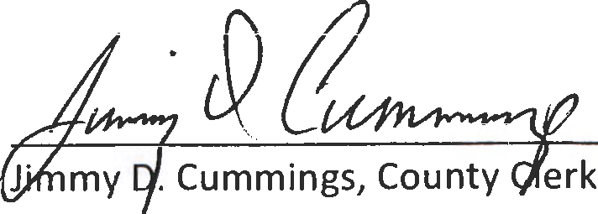

ACA 14-14-905(d)(l)(A)
Gary Spears, County Judge

