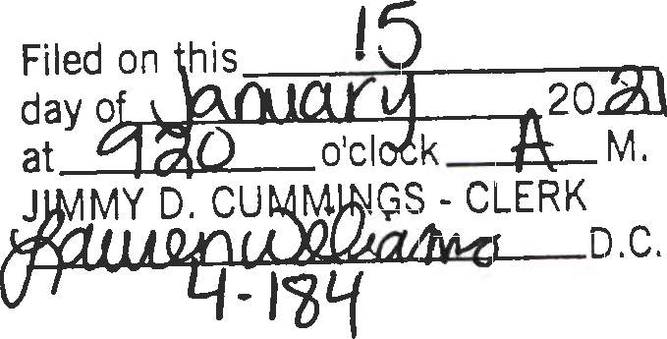
ORDINANCE# 2021 - _2

AN ORDINANCE ESTABLISHING A MEMBER OF THE CLEVELAND COUNTY QUORUM COURT AS MODERATOR OF QUORUM COURT MEETINGS IN THE ABSENSE OF THE COUNTY JUDGE:

BE IT ORDAINED BY THE QUORUM COURT OF CLEVELAND COUNTY, ARKANSAS.

SECTION ONE. In order to continue with the proper and efficient management of the county government with Cleveland County, it has been determined that a Moderator should be selected from within the Quorum Court to preside during Quorum Court meetings in the absence of the County Judge; and
SECTION TWO. By virtue of the passage of this Ordinance, the Moderator so selected shall have same powers as County Judge during Quorum Court meetings, but not to exceed any powers that would prove contrary or be in conflict with laws within the State of Arkansas; and

SECTION THREE. By passage of this Ordinance in no way implies any additional power or authority given to the Moderator when the County Judge is present to preside over meetings; and
SECTION FOUR. By passage of this Ordinance, the Moderator shall also have authority to preside over not only regular monthly meetings, but also shall have authority to preside over any special called meetings; and
SECTION FIVE. The Cleveland County Quorum Court meeting in regular session on January 7, 2021 nominated and passed upon the name of DONNIE HERRING to serve
as Moderator for the calendar year 2021.

Dated this 7th day of January, in the year of our Lord, Two Thousand and Twenty One. APPROVED:

- ·'

ACA 14-14-905(d)(l)(A)

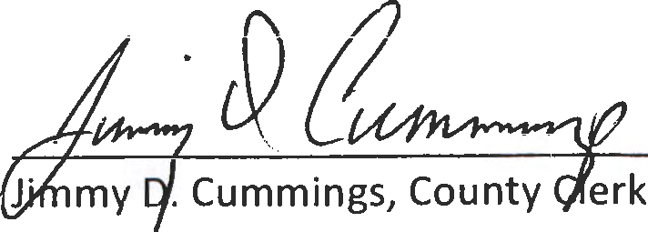
Gary Spears, County Judge ATTEST:

