ORDINANCE# 2021 - 3

BE ORDAINED BY THE QUORUM COURT OF CLEVELAND COUNTY, STATE OF ARKANSAS:

SECTION ONE: That the Quorum Court of Cleveland County, following the guidelines set out in ACT 1262 of 1995 by the State Legislature, does hereby d signate the office of the Cleveland County Sheriff to be the primary responsible party for the collection of fines and fees assessed in the Circuit Courts except; That the Circuit Clerk will be the primary responsible party fo·r collection of juvenile fees juvenile restitution and child support cases of the County. That the District Court Clerk of Cleveland County be the primary responsible party for the collection of fines and fees assessed in the District Court.

SECTION TWO: This Ordinance shall take effect and be in full force beginning January 1, 2021 through December 31, 2021.

Approved this 7th day of- January, in the Year of our Lord, Two Thousand and Twenty One.

ACA 14-14-905(d)(l)(A)
Gary Spears, County Judge

ATTEST:

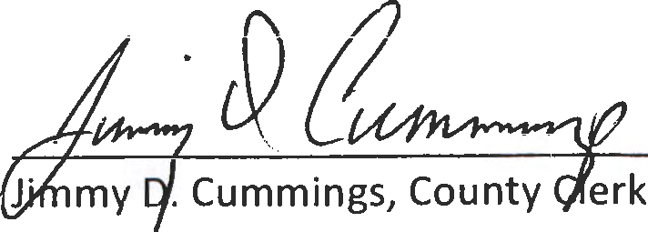

County/Circuit Clerk

