STATE TERM CONTRACT

THIS IS A TERM CONTRACT ISSUED BY THE OFFICE OF STATE PROCUREMENT. THIS DOES NOT REPRESENT YOUR AUTHORITY TO SHIP. THE ORDERING AGENCY WILL ISSUE A PURCHASE ORDER TO AUTHORIZE SHIPMENT. THIS CONTRACT CONSTITUTES ACCEPTANCE OF YOUR BID ALONG WITH ALL TERMS AND CONDITIONS THEREIN AND SIGNIFIES THE OFFERER'S KNOWLEDGE AND ACCEPTANCE OF ALL TERMS AND CONDITIONS SET FORTH WITHIN THE INVITATION FOR BID

BUYER: Tim O’Brien @ 501-324-9320 CONTRACT #: SP-13-0230R

DESCRIPTION: Awarded Furniture Categories; Cafeteria, Lounge, School, Seating

CONTRACT PERIOD: The term of this contract shall be for a period of (12) months from date of contract award with option to renew in six (6) one (1) year increments or a portion thereof upon mutual agreement. In no event shall the total contract term be more than seven (7) years.

DELIVERY REQUIREMENTS: PRICES ARE F.O.B. DESTINATION

INVOICE and FOB DELIVERY LOCATION: AS SPECIFIED ON AGENCY PURCHASE ORDER

KFI Seating
1533 Bank Street
Louisville, KY 40201

CONTACT NAME: Chris Smith
PHONE: 800-457-5078
FAX: 502-585-4676
EMAIL: csmith@kfiseating.com
VENDOR NUMBER: 100206401

CONTRACT AWARD TO:

AUTHORIZED DEALER LISTING: See Page Two

STATE OF ARKANSAS OFFICE OF STATE PROCUREMENT

BY: ____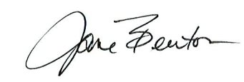___ DATE: __January 1, 2014_________

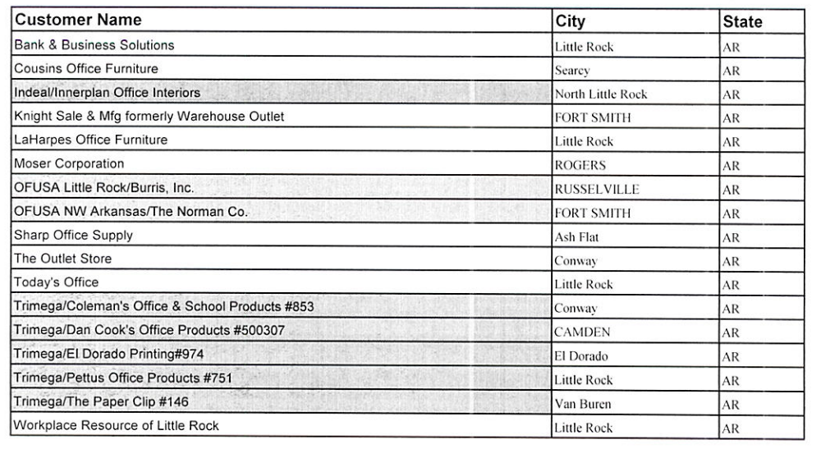
EVO Business Environments
415 N. McKinley St. Ste. 710
Little Rock, AR 72205

SECTION 1 - GENERAL INFORMATION

1.1 INTRODUCTION: This is a non-mandatory statewide contract for the design, purchase, delivery and/or assembly/set-up of Office Furniture including accessories, replacement parts and attachments including any and all associated costs for delivery, set-up and debris removal including cartons and pallets from the premises.

1.2 COOPERATIVE PURCHASING PROGRAM PARTICIPATION: Arkansas' Purchasing Law provides that local public procurement units (counties, municipalities, school districts, certain nonprofit corporations, etc.) may participate in state purchasing contracts. The contractor therefore agrees to sell to Cooperative Purchasing Program participants at the option of the program participants. Unless otherwise stated, all standard and special terms and conditions listed within the contract must be equally applied to such participants.

1.3 TYPE OF CONTRACT: The contract will be a one (1) year term contract from the date of award. Upon mutual agreement by the contractor and OSP, the contract may be renewed on a year-to-year basis, for up to (six (6)) additional (one year terms) or a portion thereof. In no event shall the total contract term be more than seven (7) years.

1.4 PAYMENT AND INVOICE PROVISIONS: An itemized invoice addressed to the ordering entity shall reference purchase order number, contract number, quantity, description, list and net unit price. Installation/Labor and any other ancillary charges will be shown as a separate line item on all quotes and invoices.

Payment will be made in accordance with applicable State of Arkansas accounting procedures upon acceptance by the Agency. The State may not be invoiced in advance of delivery and acceptance of any commodity. Payment will be made only after the contractor has successfully satisfied the state agency as to the goods purchased. Contractor should invoice agency by an itemized list of charges. Purchase Order Number and/or Contract Number should be referenced on each invoice.

1.5 RECORD RETENTION: The contractor shall be required to maintain all pertinent financial and accounting records and evidence pertaining to the contract in accordance with generally accepted principles of accounting and other procedures specified by the State of Arkansas. Access will be granted upon request, to State or Federal Government entities or any of their duly authorized representatives.

Financial and accounting records shall be made available, upon request, to the State of Arkansas' designee at any time during the contract period and any extension thereof, and for five (5) years from expiration date and final payment on the contract or extension thereof.

1.6 PRIME CONTRACTOR RESPONSIBILITY: The contractor will be required to assume prime contractor responsibility for the contract and will be the sole point of contact with regard to all commodities, services and support. The prime contractor may delegate facilitation of contract orders to their “Authorized/Certified Dealers” only. This delegation will in no way relieve the contractor of any contractual obligations set forth in this Contract Award.

1.7 CONTRACT INFORMATION
- The State of Arkansas may not contract with another party:
- Upon default, to pay all sums to become due under a contract.
- To pay damages, legal expenses or other costs and expenses of any party.
- To conduct litigation in a place other than Pulaski County, Arkansas
- To agree to any provision of a contract; which violates the laws or constitution of the State of Arkansas.
- A party wishing to contract with the State of Arkansas should:
- Remove any language from its contract which grants to it any remedies other than:
  - The right to possession.
  - The right to accrued payments.
  - The right to expenses of de-installation.
  - The right to expenses of repair to return the equipment to normal working order, normal wear and tear excluded.
  - The right to recover only amounts due at the time of repossession and any unamortized nonrecurring cost as allowed by Arkansas Law.
- Include in its contract that the laws of the State of Arkansas govern the contract.
- Acknowledge that contracts become effective when awarded by the State Procurement Official.

1.8 CONDITIONS OF CONTRACT: The contractor shall at all times observe and comply with federal and State laws, local laws, ordinances, orders, and regulations existing at the time of or enacted subsequent to the execution of this contract which in any manner affect the completion of the work. The contractor shall indemnify and save harmless the agency and all its officers, representatives, agents, and employees against any claim or liability arising from or based upon the violation of any such law, ordinance, regulation, order or decree by an employee, representative, or subcontractor of the contractor.

1.9 STATEMENT OF LIABILITY: The State will demonstrate reasonable care but shall not be liable in the event of loss, destruction, or theft of contractor-owned items to be delivered or to be used in the installation of deliverables. The contractor is required to retain total liability until the deliverables have been accepted by the “authorized agency official.” At no time will the State be responsible for or accept liability for any contractor-owned items.

1.10 AWARD RESPONSIBILITY: The State Procurement Official will be responsible for award and administration of any resulting contract.

1.11 DELEGATION AND/OR ASSIGNMENT: The contractor shall not assign the contract in whole or in part or any payment arising there from without the prior written consent of the State Procurement Official. The contractor may delegate facilitation of contract orders to their “Authorized/Certified Dealers” only. This delegation will in no way relieve the contractor of any contractual obligations set forth in this Contract Award.

1.12 DISCOUNT CHANGE CLAUSE: The contractor may offer larger discount percentages for products,
accessories, replacement parts and attachments at any time during the contract term.

1.13 LENGTH OF PRICE GUARANTEE: Discount percentages shall be firm for the term of the contract.

1.14 DELIVERY: FOB DESTINATION, INSIDE DELIVERY, FREIGHT PAID: Whenever possible, contractors should give the ordering entities 3 working days prior notice of any deliveries and/or installations. Furniture contractors will not be responsible for the removal/moving of existing furnishings unless requested by the ordering entity. Contractors should verify site readiness prior to delivery. All deliveries will be made during normal working hours unless otherwise arranged with the ordering entity. Contractor will communicate any scheduling delays and/or changes immediately. Agencies will not be responsible for any freight damage, concealed or otherwise.

1.15 SPECIAL DELIVERY INSTRUCTIONS: All shipments will be FOB destination (as specified on Ordering Entity Purchase Order).

Delivery/Installation Instructions:
Due to the varying locations and circumstances involved in deliveries and installations, all deliveries and installations will be quoted on a project by project basis.

All installation, labor, and or delivery charges must be shown as a separate line item on quotes and invoices.

One of the following delivery methods must be specified on every Agency Purchase Order:

(1) Drop Shipped: Off loaded by carrier to an Agency loading dock or designated area. There will be no charge to the ordering Agency for this delivery method.

(2) Inside Delivery: Off loaded, un-boxed/wrapped and placed in pre-determined locations within the building.
Contractor will be responsible for the removal of any trash, packaging materials, and cartons associated with the delivery.

(3) Delivered and Installed: Off loaded, and installed. Installation shall include but not limited to; any and all labor, material, and tools necessary to install furniture in accordance with approved plans and specifications and/or the direction of authorized agency personnel. The installation company will be responsible for the removal of any trash, packing material, and cartons associated with their installation.

The contractor/installation company will repair/replace (to the satisfaction of the ordering entity) any damage to
the building or its’ contents that they (the contractor) caused in the course of their work. This includes but is not
limited to: walls, floors, floor coverings, ceilings, elevators, doors, doorways, and any existing fixtures and
furniture. The agency may withhold payment until repairs are satisfactorily completed.

1.16 ACCEPTANCE STANDARDS: Inspection and acceptance/rejection of products shall be made within thirty (30) days of receipt or upon completion of installation should that installation period extend beyond thirty (30) days. Ordering entity shall have the option to return any products within the thirty (30) days.

Return Requirements: Ordering entity shall coordinate returns with the Contractor. Upon notification by the ordering entity of a duplicate shipment, over-shipment or shipment in poor condition, the products must be promptly removed at the contractor and/or dealer’s expense. Ordering entities reserve the right to return products for defects in material and/or workmanship. In the event of product return, the ordering entity reserves the right to accept either a full refund for the returned product or a replacement of the product.

Performance Requirements:: The ordering entity reserves the right to inspect and verify that all deliveries are in accordance with specifications, both at the point of delivery and at the point of use. For orders that specify an “authorized party” to receive and inspect deliveries and/or installations, acceptance and inspection procedures must be performed by the” authorized party” to be considered and accepted by the ordering entity. Products inspected at the time of use are subject to refusal and return requirements for issues of quality such

as defects in manufacturing and/or workmanship. Products will not be considered accepted by the ordering entity until the installation is complete for the applicable products.

1.17 CANCELLATION: In the event the State no longer needs the service or commodity specified in the contract or purchase order due to program changes, changes in laws, rules, or regulations, relocation of offices, or lack of appropriated funding, the State may cancel the contract or purchase order by giving the contractor written notice of such cancellation thirty (30) days prior to the date of cancellation.

SECTION 2 - SPECIFIC REQUIREMENTS

2.1 QUALITY: The items must be in conformance with normal industry standards as specified within this Contract Award.

2.2 GUIDELINES: The Office of State Procurement adheres to all guidelines set forth by the State and Federal Government concerning The Americans with Disabilities Act (ADA) as well as all mandated fire codes.

2.3 ORDERING PROCEDURE: Orders placed against this contract may be in the form of an agency issued purchase order on an as-required basis. Or an agency may also use the Arkansas State Purchasing Card (P-Card) to purchase furniture.

2.4 QUANTITY BASIS OF CONTRACT – NO GUARANTEED QUANTITIES: The contract established has no guarantee of any specific quantity and the State is obligated only to buy that quantity which is needed by its agencies.

2.5 MINIMUM ORDER QUANTITY: The State makes no commitment to purchase any minimum or maximum quantity, or dollar volume of products from the selected suppliers. Utilization of this agreement will be on an as needed basis by State Agencies and/or Cooperative Participants, Cities, Counties, Schools K-12, Colleges and Universities. The State will award to multiple suppliers; however, the State reserves the right to purchase like and similar products from other suppliers as necessary to meet operational requirements.

Note: Issuance of an award does not guarantee an order.

2.6 reporting requirements: The product manufacturer agrees to provide a yearly sales report to the Office of State Procurement. This report is due on the 15th of July following the year's activity. The report must include the total sales of all furniture orders against the contract. The report should include the following: reporting time period, manufacturer/dealer name, furniture category, quantity and dollar value of each item sold, and the name of the purchasing entity.

Note: OSP reserves the right to request a sales report on an as-needed basis.

Send report to:

Office of State Procurement
Attn: Tim O’Brien
Room 300
1509 W. 7th Street,
Little Rock, AR 72201-3966
Timothy.O’Brien@dfa.arkansas.gov

2.7 FURNITURE CLASSIFICATIONS: Furniture classifications include but not limited to: Cafeteria, Dormitory, Library Shelving and Library Related, Lounge, Systems (Modular), School (Classroom), Freestanding, Seating, Filing Systems and Equipment, and Technology Support.

2.8 GENERAL DEFINITION OF PRODUCTS
Item 1: Cafeteria Furniture

- Mobile tables on rollers with or without benches or stools.

- Round and rectangular cafeteria tables without benches or stools.

Item 2: Dormitory Furniture

- Metal, wood, or wood clad metal wardrobes, beds and mattresses, night stands, chest of drawers, and single pedestal dormitory student desks with keyboard or center drawers.

Item 3: Library Shelving and Library Related Furniture

- Cantilever, reversed cantilever, four post library shelving (all of which include mobile shelving), and end panels for covering end of panels.

- Library Related Furniture, which includes but not limited to: book trucks, circulation desks, library tables, card catalogs, study carrels, storage cabinets, periodical racks, dictionary stands, and display cases.

Item 4: Lounge Furniture

- Upholstered wood, metal, or rotationally molded lounge seating which includes but not limited to: (lounge chairs, recliners, love seats, sofas, and assemblies and replacements only).

- Complimentary tables, benches, and ottomans for lounge seating. Manufacturers must have lounge seating to match tables, benches and ottomans.

- Upholstered wood or metal multiple seating, ganging seating, and tandem seating.

Item 5: Systems Furniture (Modular)

- A complete and comprehensive catalog of all systems furniture, including modular work stations, lines and accessories.

- Metal, wood or laminate modular furniture, these can include complimentary components such as keyboard drawers, task lights, tack boards, etc. and storage units.

Item 6: School Furniture (Classroom)

- Student desk, chair desks, tablet arm chairs and stools.

- Single unit pedestal teacher's desks

- Study carrels and storage cabinets

- Stacking chairs, student chairs and folding chairs

- Classroom activity, computer, folding, training tables and accessories, such as, ganging devices, electrical/data components and storage dollies.

Item 7: Freestanding/Casegoods Furniture

- A complete and comprehensive catalog of all case goods, furniture, (including folding and mobile) desks and tables.

- Conference room tables, lecterns, media cabinets, storage cabinets and presentation boards

Item 8: Seating

- A complete and comprehensive catalog of chairs, auditorium and general seating.

- Wood, metal or ergonomic seating which may include but limited to: executive, managerial, task, operational, stools, side, occasional, stacking, conference, and theater type seating.

- Products must meet or exceed ANSI/BIFMA requirements.

Item 9: Filing Systems and Equipment

- A complete and comprehensive catalog of filing systems including vertical and lateral files, bookcases, mobile cabinets and freestanding file cabinets.

Item 10: Technology Support Furniture

- A complete and comprehensive catalog of technology support furniture to support technology based learning environments.

ANY PERMANENT FURNITURE INSTALLATION for State Agencies as well as requested space alterations, attached fixtures, furnishings and erected additions must have Arkansas Building Authority (ABA) approval if:

- The building is owned by ABA and/or
- The product and installation exceeds the sum of $20,000.00.
(Excluding ABA exempt agencies)

Note: the Americans with Disabilities ACT and the Arkansas Fire Codes must be adhered to as set forth by local and federal guidelines by the ordering entity and the contractor.

Codes, Permits, Licenses for Permanent Installation:
The contractor must comply with all State mandatory licensing requirements prior to installation. Questions on licensing requirements should be directed to the State Licensing Board. Contractor must furnish and install all furniture and materials in compliance with all applicable codes, whether local, state, or federal; and that all permits or licenses required for installation will be obtained without cost to the State.

2.9 PRODUCT MANUFACTURER'S SUPPLIERS: Only those dealers/distributors listed by the manufacturer will be considered authorized to act on behalf of the Product Manufacturer.

2.10 CONTRACT RENEWAL PERIOD: FURNITURE ADDITIONS/DELETIONS: Contractors wishing to make furniture additions/changes to their contract during the contract period should be aware of the following

additions/changes will be allowed only once during a contract period. No changes to discount percentages are allowed during this contract period.

Additions/changes must be submitted during the contract renewal period.

When requesting additions and/or changes; contractor shall submit a request either by letter or via email which shall include a list of all items being proposed for addition and/or change.

Contractor shall submit all required documents supporting any new items.

Product literature for all new items shall also be submitted with the request.

Contractor is responsible for submitting a complete name, address, email address, phone and fax numbers when a new dealer is added.

2.11 PRICE LISTS AND PRODUCT INFORMATION: Contractors should provide an electronic version of the proposed price list in an Excel format or pdf on a jump drive. Also provide a dealer list, if applicable in an Excel format with "read and write" capabilities on the same jump drive. No costs or expenses associated with providing this information in the required format shall be charged to the State of Arkansas. At the time of contract renewal contractor will furnish OSP with an updated dealer list and published price list.

2.12 LITERATURE: The manufacturer/dealer shall furnish price lists, catalogs, and description literature upon request by any using entity, and at no cost to the entity.

2.13 SPECIAL PACKAGING: Items shall be packaged and cartoned so as to protect the contents from damage during shipment, handling and storage. Shipping container shall have a label with the following information:
Name of Receiving Agency
Agency Purchase Order Number
Name of Supplier
Item Description of Contents
Manufacturer Name
Model Name and Number

2.14 WARRANTY: Minimum acceptable warranty will be for a period of one year from the date of product acceptance by the ordering entity. Warranty shall cover defects in material and workmanship and shall cover all costs associated with the repair or replacement of defective items including labor, parts, transportation costs, travel time and expense, and any other costs associated with such repair or replacement.

If anytime during the first (1) year warranty period the product does not perform in accordance to manufacturer’s specification, the successful contractor will be notified in writing. The contractor shall pick up the product at the contractor’s expense, and replace with product that meets or exceeds prior assembled product. Should product performance remain unacceptable to ordering entity, entity may request a full return of the purchase price (including taxes).

2.15 ORDER CANCELLATION: Users of this contract are advised that orders (all or part) cancelled or returned after acceptance of requested merchandise will be subject to a restocking fee of ten percent (10%) of the invoice amount (not to exceed $500.00 per order) plus return freight charges. The amount authorized for payment of return freight will, in no instance, be more than original delivery charges documented by carrier. These charges may be applied, at the option of the supplier, to those orders which have been accepted. Orders cancelled prior to shipment or acceptance by ordering entity from the manufacturer will not be assessed charges.

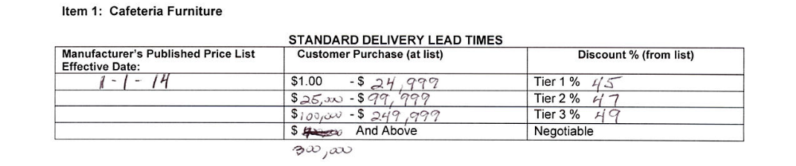

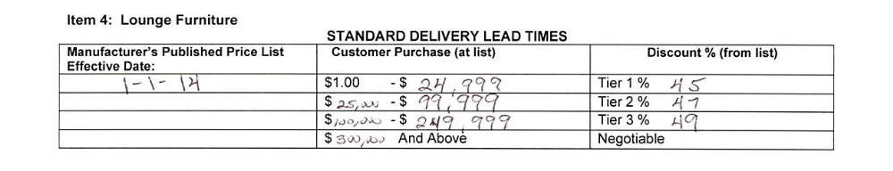
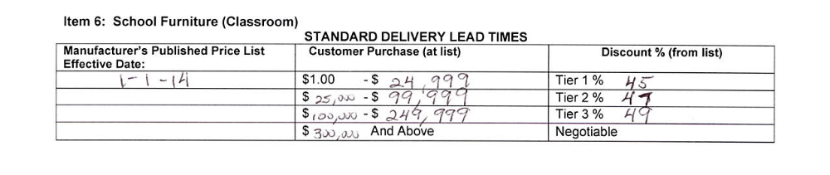
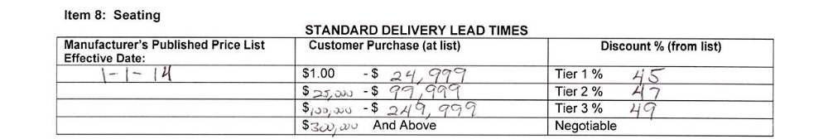

TERMS AND CONDITIONS
1. GENERAL: All terms and conditions stated in the invitation for bid govern this contract
2. PRICES: Prices are firm and not subject to escalation, unless otherwise specified in the invitation for bid.

3. DISCOUNTS: All cash discounts offered will be taken if earned.

4. TAXES: Most state agencies must pay state sales tax. Before billing, the contractor should contact the ordering agency to find out if that agency must pay sales tax. Itemize state sales tax when applicable on invoices.

5. BRAND NAME REFERENCES: The contractor guarantees that the commodity delivered is the same as specified in the bid.

6. GUARANTY: All items delivered are to be newly manufactured, in first- class condition, latest model and design, including, where applicable, containers suitable for shipment and storage unless otherwise indicated in the bid invitation. The contractor guarantees that everything furnished hereunder will be free from defects in design, workmanship, and material; that if sold by drawing, sample or specification, it will conform thereto and will serve the function for which furnished. The contractor further guarantees that if the items furnished hereunder are to be installed by the contractor, such items will function properly when installed. The contractor also guarantees that all applicable laws have been complied with relating to construction, packaging, labeling, and registration. The contractor's obligations under this paragraph shall survive for a period of one year from the date of delivery, unless otherwise specified in the invitation for bid.

7. AWARD: This contract award does not authorize shipment. Shipment against this contract is authorized by the receipt of a purchase order from the ordering agency. A written purchase order mailed or otherwise furnished to the contractor results in a binding obligation without further action by either party.

8. DELIVERY: The term of the contract is shown on the face of the contract award. The contractor is required to supply the state's needs during this term. The number of days required to place the commodity in the receiving agency's designated location under normal conditions is also shown. Consistent failure to meet delivery without a valid reason may cause removal from the bidders' list or suspension of eligibility for award.

9. BACK ORDERS OR DELAY IN DELIVERY: Back orders or failure to deliver within the time required may be default of the contract. The contractor must give written notice to the Office of State Procurement and ordering agency of the reason and the expected delivery date. If the reason is not acceptable, the contractor is in default. The Office of State Procurement has the right to extend delivery if reasons appear valid. If the date is not acceptable, the agency may buy elsewhere.

10. DELIVERY REQUIREMENTS: No substitutions or cancellations are permitted without written approval of the Office of State Procurement. Delivery shall be made during agency work hours only, 8:00 a.m. to 4:30 p.m., unless prior approval for other delivery has been obtained from the agency. Packing memoranda shall be enclosed with each shipment.

11. STORAGE: The ordering agency is responsible for storage if the contractor delivers within the time required and the agency cannot accept delivery.

12. DEFAULT: All commodities furnished will be subject to inspection and acceptance of the ordering agency after delivery. Default in promised delivery or failure to meet specifications authorizes the Office of State Procurement to cancel this contract or any portion of same and reasonably purchase commodities elsewhere and charge full increase, if any, in cost and handling to the defaulting contractor.

13. VARIATION IN QUANTITY: The state assumes no liability for commodities produced, processed or shipped in excess of the amount specified herein.

14. INVOICING: The contractor shall submit an itemized invoice showing the bid number and purchase request number when itemized in the invitation for bid. Invoices must be sent to "Invoice to" point shown on the purchase order.

15. STATE PROPERTY: Any specifications, drawing, technical information, dies, cuts, negatives, positives, data or any other commodity furnished to the contractor hereunder or in contemplation hereof or developed by the contractor for the use hereunder shall remain property of the state, be kept confidential, be used only as expressly authorized, and be returned at the contractor's expense to the F.O.B. point, properly identifying what is being returned.

16. ASSIGNMENT: This contract is not assignable nor the duties hereunder delegable by either party without the written consent of the other party to the contract.

17. OTHER REMEDIES: In addition to the remedies outlined herein, the contractor and the state have the right to pursue any other remedy permitted by law or in equity.

18. LACK OF FUNDS: The state may cancel this contract to the extent funds are no longer legally available for expenditures under this contract. Any delivered but unpaid for goods will be returned in normal condition to the contractor by the state. If the state is unable to return the commodities in normal condition and there are no funds legally available to pay for the goods, the contractor may file a claim with the Arkansas Claims Commission. If the contractor has provided services and there are no longer funds legally available to pay for the services, the contractor may file a claim.

19. QUANTITIES: The state may order more or less than the estimated quantity in the invitation for bid.

20. DISCLOSURE: Failure to make any disclosure required by the Governor's Executive Order 98-04, or any violation of any rule, regulation, or policy adopted pursuant to that order, shall be a material breach of the terms of this contract. Any contractor, whether an individual or entity, who fails to make the required disclosure or who violates any rule, regulation, or policy shall be subject to all legal remedies available to the agency.

