Agency #108.00

RULES

FOR

POLL WORKER & COUNTY CLERK

TRAINING

(Effective March 17, 2002; Revised ____)

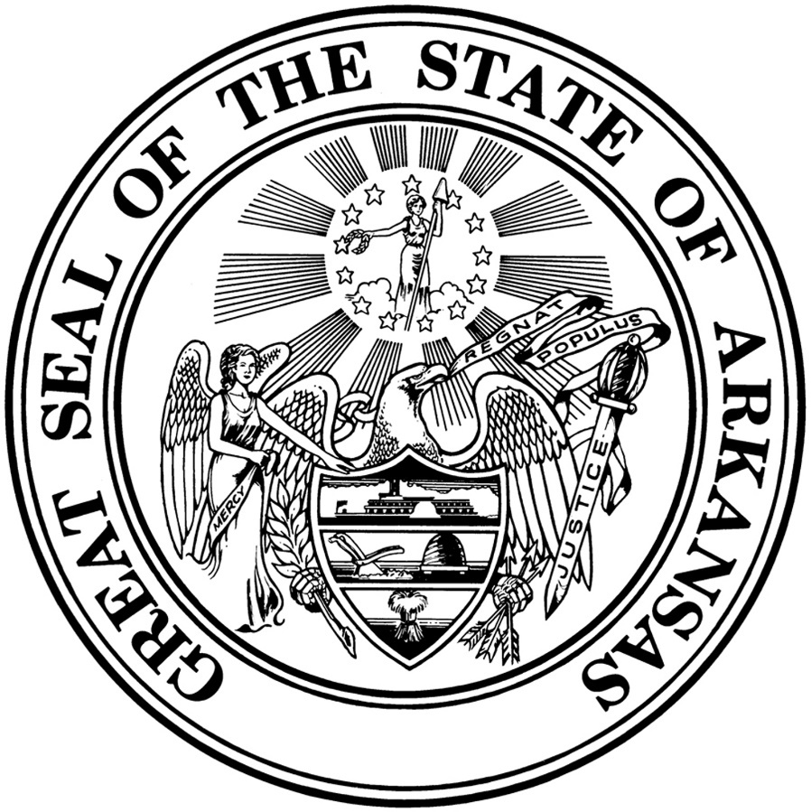

State Board of Election Commissioners
501 Woodlane, Suite 401N
Little Rock, AR 72201
(501) 682-1834 or (800) 411-6996
www.arkansas.gov/sbec

TABLE OF CONTENTS

Scope of Rules 3

§ 200 Definitions 3

§ 201 Qualifications of Election Officials Designated as Poll Workers 3

§ 202 Required Training 4

§ 203 Certification and Compensation of Poll Worker Trainers 4

§ 204 Compensation for Poll Worker Training Attendance 5

§ 205 Required Training for County Clerks 5

§ 206 Noncompliance 6

§ 207 Training Materials 6

Scope of Rules

These rules will set forth the methods for coordinating training on early voting and election day procedures for poll workers and county clerks in the 75 counties in the state. These rules are in addition to, and not a substitute for, the laws of the State of Arkansas.

§ 200 Definitions

- Election Official – a person who is a member of the county board of election commissioners, a person who performs election coordinator duties, a person who is a poll worker designated by a county board of election commissioners to be an election clerk, election judge, or election sheriff, or a deputy county clerk or a person assigned by a county clerk to conduct early voting.

- Polling Site – a location selected by the county board of election commissioners where votes are cast.

- Poll Worker – an election official designated by the county board of election commissioners to be an election clerk, election judge, or election sheriff at a polling site.

- Precinct – a geographical area the boundaries of which are determined by a county board of election commissioners in order to facilitate voting by the registered voters from that geographical area.

- Primary Election – any election held to select the nominees of a political party for election at any general or special election in this state.

§ 201 Qualifications of Election Officials Designated as Poll Workers

The qualifications determined by the General Assembly of an election official designated by the county board of election commissioners to serve as a poll worker are as follows:
- Must be a qualified elector of this state;
- Must be able to read and write the English language;
- Must be a resident of a precinct permitted to vote at the polling site in which he or she serves at the time of his or her appointment, unless the county board determines unanimously that it is impossible to obtain qualified poll workers from the precinct, in which case, the poll worker shall be a qualified county resident;
- Must not have been found guilty or pled guilty or nolo contendere to the violation of any election law of this state;
- Must not be a paid employee of any political party;
- Must not be a paid employee of any person running for any office on the county’s ballot;
- Must not be a candidate for any office to be filled at an election while serving as a poll worker;
- Must not be married to or related within the second degree of consanguinity to any candidate running for office in the current election if objection to the service is made to the county board of election commissioners within ten (10) calendar days after the posting of the list of officials;
- Must not be the spouse of a member of the county board of election commissioners if objection to the service is made to the county board of election commissioners within ten (10) calendar days after the posting of the list of officials; and
- Must not be the chairman or the spouse of a chairman of a county political party if objection to the service is made to the county board of election commissioners within ten (10) calendar days after the posting of the list of officials.

§ 202 Required Training

Each county board of election commissioners shall:

- Designate at least two (2) qualified electors of the county to attend training conducted by the State Board of Election Commissioners before the regularly scheduled preferential primary election for the purpose of being certified by the State Board as poll worker trainers for the county. Each designee shall attend either a comprehensive training program conducted by the State Board of Election Commissioners before the regularly scheduled preferential primary election or an advanced training program conducted by the State Board of Election Commissioners after each regular legislative session. Any designee who has not served as a certified poll worker trainer during the previous two (2) preferential primary and general elections and previously attended the comprehensive training program conducted by the State Board of Election Commissioners must attend the comprehensive training program;
- Ensure that all poll workers at each preferential primary election polling site for a regularly scheduled election attended election training conducted locally by State Board-certified trainers and coordinated by the State Board prior to each regularly scheduled preferential primary election; and
- For all elections following the regularly scheduled primary election, ensure that each poll worker has attended election training coordinated by the State Board within twelve (12) months prior to the election in which they are serving.

§ 203 Certification and Compensation of Poll Worker Trainers

Upon successful completion of training conducted by the State Board of Election Commissioners:

- Certification, valid for a period of two (2) years, shall be issued by the State Board to each designated trainee who successfully completes the training program;
- A maximum of two (2) certified trainers per county are eligible to receive $100 each, plus mileage reimbursement at the rate established for state employees by state travel regulations;
- The two (2) certified trainers per county are eligible to receive an additional $50 each per training session up to a maximum of two (2) sessions each for conducting poll worker training locally before the preferential primary election; and
- Certified trainers’ compensation will be paid by the State Board to the County Treasurer upon receipt of the reporting form approved and provided by the State Board to the county for that purpose.

Certification and compensation of additional county trainers will be considered by the State Board on a case by case basis based upon need and availability of sufficient resources and funding. The compensation of the certified trainers for more than two training sessions will also be considered by the State Board on a case by case basis based upon need and availability of sufficient resources and funding.

Request for additional certified trainers or compensation for additional training sessions in excess of the limitation established in this section must be made in writing and must describe the facts and circumstances that make the additional personnel and funding necessary for the effective training of county trainers.

§ 204 Compensation for Poll Worker Training Attendance

A poll worker who attends training conducted by a State Board-certified poll worker trainer and who works the preferential primary election immediately following the training is eligible to receive a maximum $25 additional one-time payment.

A county is eligible to receive compensation for poll worker training attendance up to a maximum of six (6) eligible poll workers per precinct per polling site per preferential primary election.

Poll worker compensation will be paid by the State Board to the County Treasurer upon receipt of suitable supporting documentation from the county, as determined by the State Board.

§ 205 Required Training for County Clerks

A county clerk or his or her designee shall attend training for poll worker trainers conducted by the State Board of Election Commissioners before the regularly scheduled preferential primary election. Each county clerk or designee shall attend either a comprehensive training program conducted by the State Board of Election Commissioners before the regularly scheduled preferential primary election or an advanced training program conducted by the State Board of Election Commissioners.

Advanced training will be made available if the Director of the State Board determines that, based on the amount of changes in law and procedure from the previous election cycle, an advanced training program is appropriate for experienced County Clerks Advanced trainings are to only be utilized for clerks or designees who are unable to attend the comprehensive training and may be conducted remotely. Advanced trainings may not include a detailed review of all basic laws and procedures which are unchanged from the previous two election cycles but will address all aspects of the duties of the county clerk’s office in conducting an election.

Any county clerk or designee who has not served as an election official during the previous two (2) preferential primary and general elections and previously attended the comprehensive training program conducted by the State Board of Election Commissioners must attend the comprehensive training program.

County clerks or clerk designees who attend training under this section are eligible to receive mileage reimbursement at the rate established for state employees by state travel regulations and are not eligible to receive any additional compensation; and

Any reimbursement will be paid by the State Board to the County Treasurer upon receipt of the reporting form approved and provided by the State Board to the county for that purpose.

§ 206 Noncompliance

The State Board may withhold funding for poll worker and county clerk training attendance from any county that fails to comply with the rules and guidelines developed by the State Board for the administration of poll worker training, until all requirements are met to the satisfaction of the State Board.

§ 207 Training Materials

The State Board of Election Commissioners will provide training materials for local poll worker training to each of the seventy-five (75) counties.

Poll worker training shall be conducted only by State Board-certified trainers. Trainers are required to use materials provided by the State Board. This requirement includes the presentation of all multi-media provided by the State Board.

Any exception to the requirements of this section must be by prior written request to the State Board with prior written approval by the State Board. Approval by the State Board is not required for materials related to voting system training or supplemental procedures not addressed by materials provided by the State Board.

A.C.A. § 7-1-101 as amended by Act 1042 of 2015
A.C.A. § 7-1-101
A.C.A. § 7-1-101
A.C.A. § 7-4-109
Art 3, § 10 of the Arkansas Constitution, as amended by Amendment 85
A.C.A. §7-4-109(e)(1)
A.C.A. § 7-4-107(b)(2)(C) as amended by Act 966 of 2019.
A.C.A. § 7-4-109(e)(2)
A.C.A. § 7-7-201(b)(3)

